**Docker Assignment 01 Asad Shaikh 10-01-2024**

1. **Docker installation**: Install Docker on your local system (Windows, macOS, or Linux). Verify the installation by running the docker --version and docker info commands.

🡪

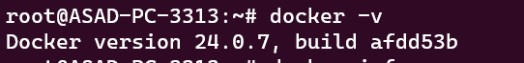

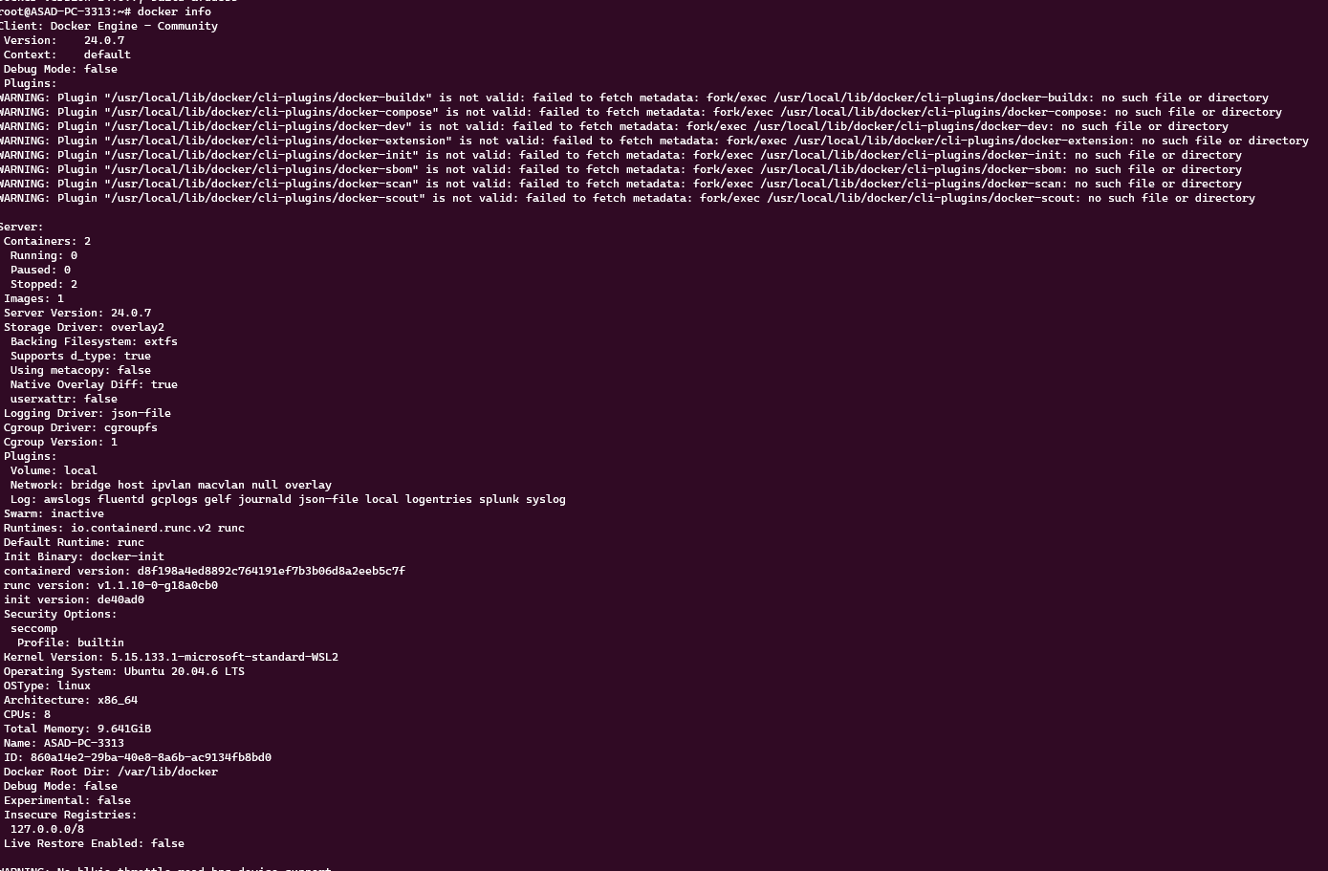

1. **Working with Docker images**: Search for the official Ubuntu image on Docker Hub, pull it to your local system using docker pull, and list all available images on your system using docker images.

🡪

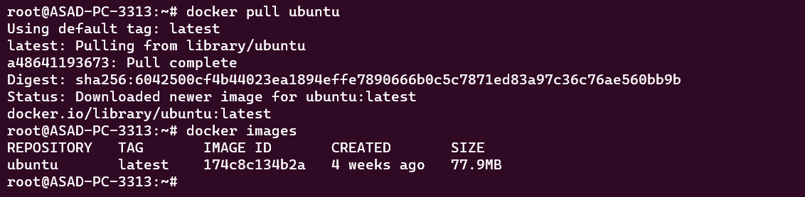

1. **Creating a Docker container**: Run a Docker container using the Ubuntu image, and execute a command inside the container (e.g., echo "Hello, Docker!").

🡪



1. Inspect the Ubuntu Docker container to ensure it is in the "created" state only.

🡪

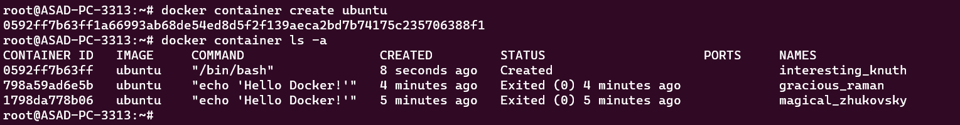

1. Execute the Ubuntu Docker container and confirm that the container's state is "running."

🡪





1. Launch an HTTP container, verify its state, and then remove the container and image from your local system.

🡪

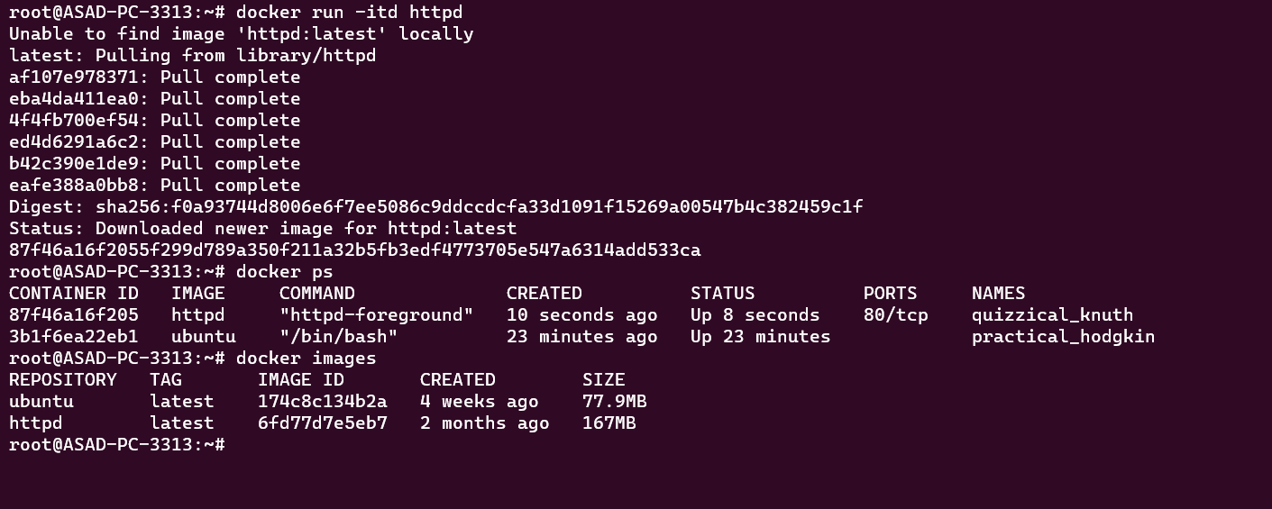

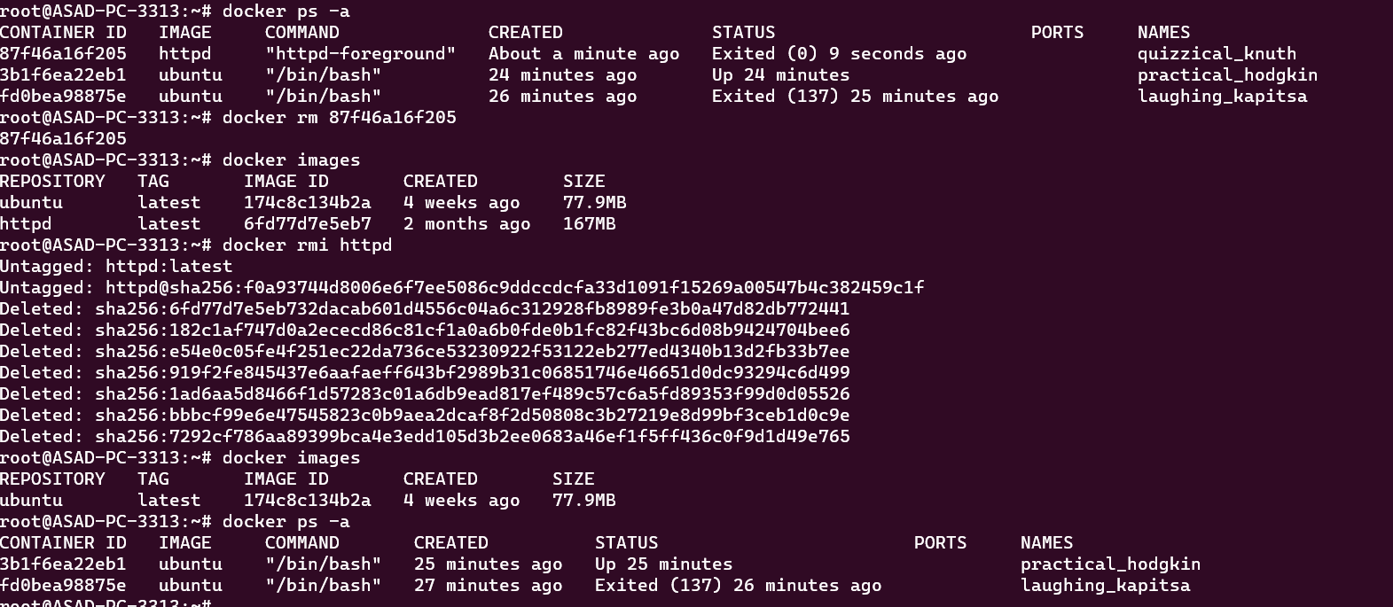

1. Execute a command to display a filtered list of containers, showing only their short container IDs.

🡪

